Holy Name Church Museum

The museum started when Father Alex Davie (2011-18) joined as Parish Priest and Tom Canning (a parishioner) had the idea to curate and organise religious artefacts for the benefit of future generations.

It is accessed by a spiral staircase to your left when you enter the main door of the church and is located where the choir was accommodated in days gone by.

Below are described just a few of the religious artefacts associated with Holy Name Church going back to the middle of the nineteenth century – if your appetite is whetted please feel free to visit. The museum is open whenever the church is open.
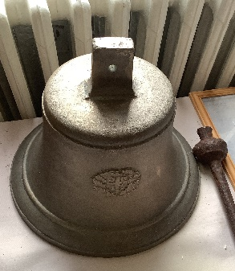
The bell at the top of the old church which was founded in 1904. It was operated by a rope. There is a picture of the bell in situ in the museum on a display board.

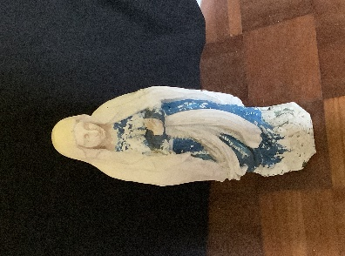
A statue of Our Lady which was originally in the grotto in the grounds of the church. The grotto is no longer there, but there is a photograph showing where she was placed, in the museum.

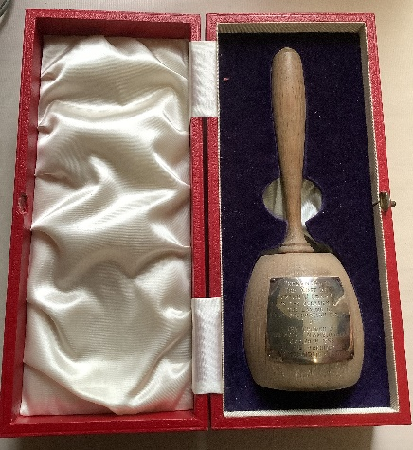
An ornamental stonemason’s mallet which was presented to Archbishop Gordon J Gray by the church’s architects when he laid the foundation stone in October 1956.

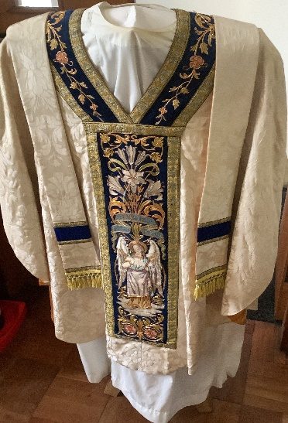
There is a selection of vestments from the new and old churches on display. Most were made by the nuns of the Carmelite order who had a convent on site – read more on our history page.

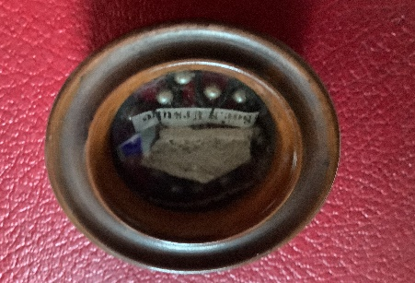
A relic of St. Ursula is on display. Other relics are in the nave of the church.

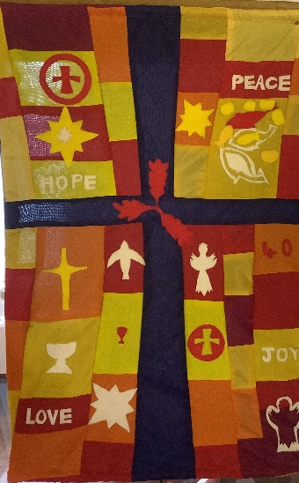
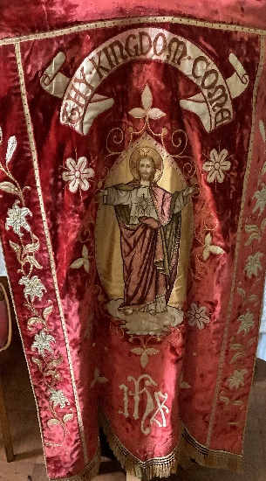

A banner made
A banner owned by Holy Name
by The Guild of Primary pupils
the Sacred Heart. to mark 40 yrs
of the new
church.

