HOLY NAME CHURCH WINDOWS AND STATIONS OF THE CROSS

The renowned French stained-glass artist, Gabriel Loire, was commissioned by the Smith-Sligo family, with the assistance of architect Charles Gray of Edinburgh, to provide stained glass windows and wooden Stations of the Cross for the new church.

Gabriel Loire
Gabriel Loire (1904-1996) already had a considerable international reputation. By 1958 he had created stained-glass windows in many churches in France, the United States, Brazil and numerous other countries.
Slab glass set in re-inforced concrete was his preferred medium at that time. It is thicker and stronger than traditional glass. For Loire; la paie donne la joie (peace gives joy). He particularly liked working with shades of blue which to him represented the colour of peace.
It is notable that at about the same time as his work with Holy Name, Loire was involved with one of his greatest and most famous works – the Kaiser Wilhelm Memorial Church in West Berlin.
The four long windows on the south side of the nave portray four simple symbols: the dove, (traditionally the Holy Spirit), fish, bread and grain provide us with spiritual and physical sustenance.
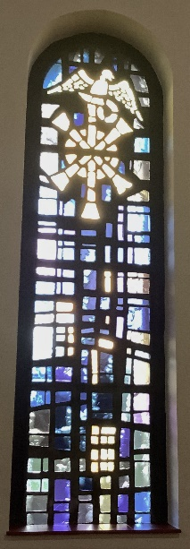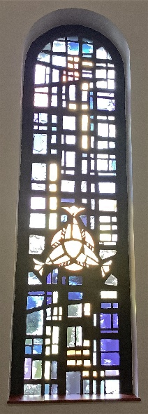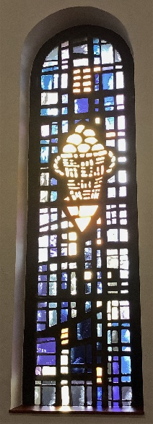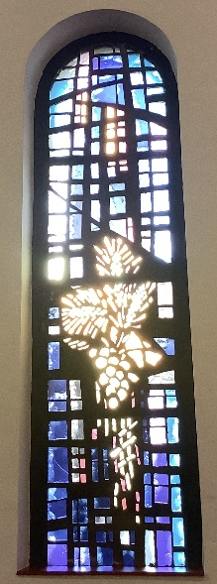
In the smaller circular windows on the north side of the nave are straightforward yet revelatory episodes which are central to Catholic belief: the Annunciation, the Birth of Jesus, the Crucifixion and the Ascension.
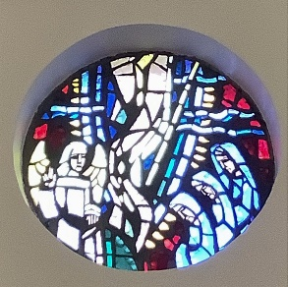
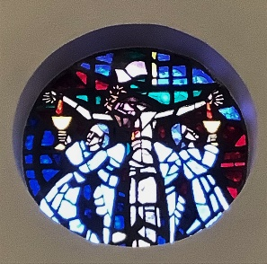
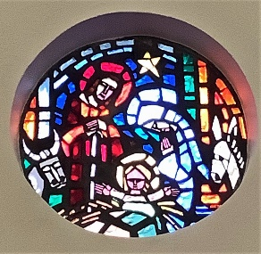
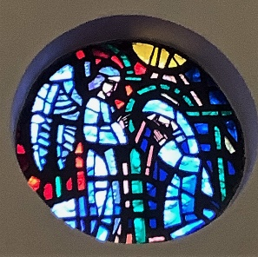
Loire’s work for Holy Name Church was not confined to the beautiful stained-glass windows. Holy Name’s carved fourteen Stations of the Cross (the last clearly bearing Loire’s signature – see below) were delivered in 1962, four years after the opening of the church.

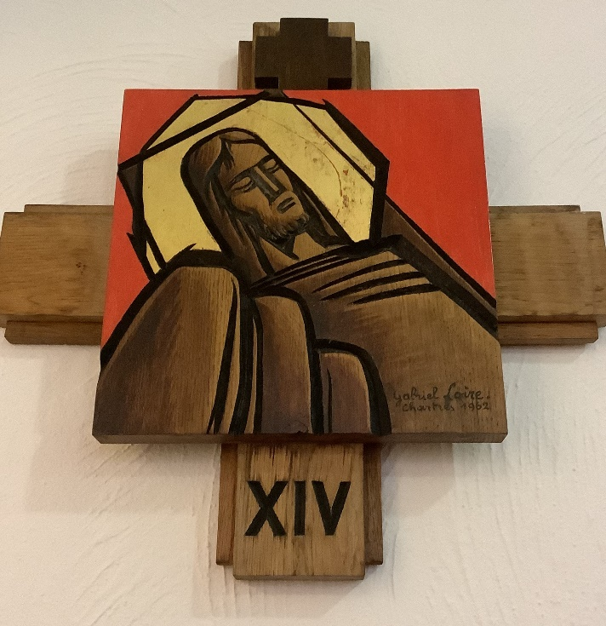

Grateful acknowledgement to John Nolan’s “A History of Holy Name Parish, Oakley”.

