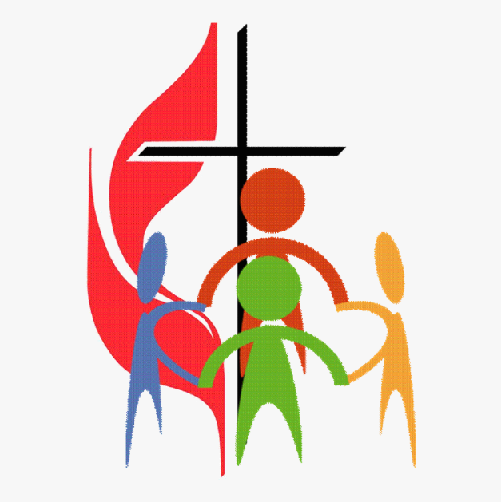

**VOICE OF THE LAITY**

The inaugural sessions of the ‘Voice of the Laity’ were held at St Margaret’s on 2nd Sept and at Holy Name on 3rd Sept 2023.

Some 25 Parishioners attended over the two sessions.

Voice of the Laity is designed as a forum for Parishioners to gather, have a cup of tea/coffee and to discuss any subject that is relevant to our Faith and our Parish. We will convene more of these sessions on a regular basis.

This note is compiled to share the discussions that took place during the two sessions.

**Saturday 2nd Sept – St Margaret’s**

Attendees initially identified the following subjects that may be considered for further discussion;

* Involvement of the Laity in support of Priests
* Education in the Faith to overcome ignorance (Adult Formation – RCIA)
* Relationship with other Churches – Non-Christian denominations
* Alternatives to consider – meditation and thoughtful prayer
* The Synod itself and what it means
* Are we practising what we preach in our daily lives

Here is some further detail of the ensuing discussions;

• More active involvement of the laity seen as a desirable since the Church needs both clergy and laity. The priests are overworked in many parishes – there is much that can be delegated to lay persons both from the administrative aspect but also more religious items where suitable laity are available e.g. Ministers of Holy Communion.

• Ignorance can give rise to unkind bias in the Church. Many of us need further education about our church because we have forgotten things or we have not kept up with changes. Adult formation is necessary in various forms – one of these is that the RCIA can have an added role in this as well as the role in preparing converts to the Church.

• Our relationship to other Christian churches should be improved .Ecumenism is explored and practiced by the other Christian churches but often the Catholic church shuns this.

• What about our relationships with non-Christian religions. Other religions can have a lot in common with us in terms of social responsibility, care of the poor and dispossessed etc. They may not share our faith making Ecumenism not possible but we should not distance ourselves from them but try to understand and maybe cooperate.

• Active groups in the parish which already undertake charitable and religious activity are not all widely known or participated in. On the charitable side this includes the SVdP and the One World Group and on the religious side there is the new contemplative meditation group. Also, some parishioners are very active in groups such as the Carmelites. Can we not expand this by more widely publicizing these groups to our parishioners in a positive way and perhaps also by encouraging other similar activities in the laity?

• The Synod on Synodality in Rome bringing together the clergy and the laity was welcomed. But there was unhappiness at the editing of parish and deanery discussion outcomes by local hierarchies before submission to Rome. By excluding suggestions and comments from the laity some bishops have silenced the laity contribution to the synod which was meant to be an important reason for holding it. Noted that not all dioceses in Britain had done this but it was noticeable to some present that the St Andrews and Edinburgh diocesan submission bore little relationship to our discussion meetings.

**Sunday 3rd Sept – Holy Name**

Attendees initially identified the following subjects that may be considered for discussion;

* Links with other Faiths and how we interact
* Churches as Learning Centres
* Can we do more about poverty
* What is the outcome of this and what is it all about
* Tell us about other Parish Groups and publicise what they do
* Married Priests, Women Priests and Deacons
* Basics of the Faith
* How do we get young people involved with the Church

Though a simple voting process, attendees decided to discuss the following subject in more detail;

**How do we get young people involved with the Church**

Listed below are some of the key comments that were raised during the healthy discussion that followed;

* Children’s Mass once a month ?
* What roles/jobs can we give to young people
* Challenge is that there are less than 20 Catholic Children attending school in Oakley
* Get the Parents to come to Church
* Stronger links to the School
* Mini-bus to get the kids transported to Church
* Caritas awards for kids – what happened – need an equivalent
* Catholic equivalent of the Duke of Edinburgh Award
* Child friendly priests – with charisma
* Youth Club
* Need for church to work with schools – primary and secondary
* Wondering why children who have had Sacraments don’t return to church
* Suggestion given that it might be a good idea to ask the children themselves why they don’t come to church
* Also ask what would encourage them to come to church
* Suggestion made that the reputation of the catholic church historically has not helped situation
* Suggestion to make people more aware of what is going on in parishes – advertise what is available
* Have churches as learning centres – looking at music and art – religious themed
* Look for times and dates to suit people